biological model & rules

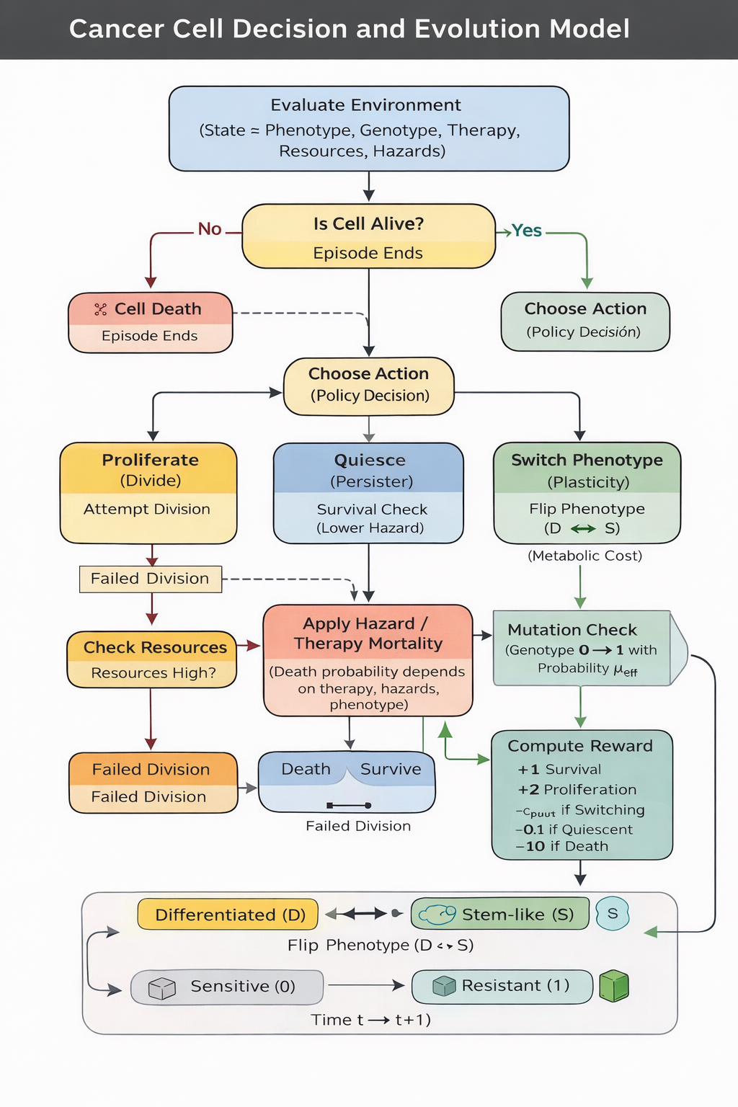

1 State space (what defines the MDP state)
A minimal but biologically meaningful state is:
State = (Phenotype, Genotype, Therapy, Resources, Hazards)
- Phenotype (P):
  - S = stem-like / plastic / slow cycling / stress-tolerant
  - D = differentiated / proliferative / therapy-sensitive
Justification: stemness is treated as a functional state and can be modulated by ecology (e.g., hypoxia) rather than being fixed.
Classifying the evolutionary an…
- Genotype (G):
  - 0 = not genetically resistant
  - 1 = genetically resistant
Justification: therapies select for resistance mutations; this is classic somatic evolution.
Cancer as an evolutionary and e…
- Therapy (T) (adaptive therapy schedule):
  - ON / OFF (or ON when tumor burden high, OFF when low)
- Resources (R):
  - High / Low (proxy for oxygen/nutrients/vasculature)
Justification: Eco-index resources include hypoxia, blood vessels, nutrients.
Classifying the evolutionary an…
- Hazards (H):
  - High / Low (proxy for therapy intensity + immune predation)
Justification: Eco-index hazards include immune infiltration and other threats.
Classifying the evolutionary an…
That gives 2×2×2×2×2 = 32 states (small enough for Q-learning).

2 Action space (what the cell-agent can do)
At each time step (generation), the agent chooses one action:
- Proliferate (A = PROLIF)
  - increases tumor burden, increases chance of being hit by therapy hazards
- Quiesce / Persister-like survival (A = QUIESC)
  - no growth, lower hazard exposure
- Plasticity switch (A = SWITCH)
  - if D → S (dedifferentiate) or S → D (differentiate)
Justification: non-genetic heterogeneity can reflect stable attractor states in GRNs; switching = transition between attractors.
Reconciling Non-Genetic Plastic…
- “Wait for mutation” is not a separate action
  - it happens naturally during proliferation through mutation probability (see below).

3 Transition rules (biology dynamics)

A) Survival / death probability
Define baseline death probability as a function of hazards/resources and phenotype:
- If Therapy ON and Hazards High, then:
  - D cells have high death probability
  - S cells have lower death probability (stress tolerant)
This is consistent with the idea that harsh microenvironments and interventions impose strong selection and reduce diversity. For example, in the microenvironment-driven selection simulations, low oxygen (harsh) reduces phenotype diversity and selects a few dominant phenotypes.
Tumor Morphology and Phenotypic…
A simple rule table:
Condition | Death prob if D | Death prob if S
Therapy ON + Hazards High + Resources Low | very high | moderate
Therapy ON + Hazards High + Resources High | high | low-moderate
Therapy OFF + Hazards Low + Resources High | low | low
Therapy OFF + Resources Low (hypoxia) | moderate | low-moderate
(Your computational teammate can turn “low/moderate/high” into numbers like 0.05 / 0.15 / 0.35 / 0.6.)

B) Growth / reproduction (fitness benefit)
If the cell survives:
- PROLIF yields a positive growth reward only if resources allow division
- S typically divides slower than D (trade-off)

C) Genetic resistance emergence (Evo-index connection)
Resistance mutation occurs mainly when dividing:
- If action = PROLIF and genotype = 0:
  - genotype becomes 1 with probability μ_eff
Make μ_eff a function of Evo-index:
- Higher D (diversity) and higher Δ (ongoing change) → higher effective mutation supply / adaptation rate.
This matches the idea that Evo-index reflects evolvability as diversity + its change over time.
Classifying the evolutionary an…
(Implementation-friendly: set μ_eff = μ0 × f(Evo), where f(Evo) is 1 for low Evo and maybe 5–10× for high Evo.)

D) Plasticity switching (non-genetic evolution rule)
If action = SWITCH:
- phenotype flips (D ↔ S) with high probability
- BUT you pay a plasticity cost (this is the parameter you sweep to find tipping point)
Justification:
- Cell states can be stable attractors; switching is a transition between attractor states.
Reconciling Non-Genetic Plastic…
- Cancer stem-like states can reflect non-genetic heterogeneity and can be dynamic.
Maryam-Non-genetic heterogeneit…

4 Reward function (this is the key biology deliverable)
You want rewards that represent fitness = survival + reproduction – costs (Merlo/Maley definition of fitness as survival + reproduction is explicitly used in this literature).
Cancer as an evolutionary and e…
Use:
Reward = (Survival bonus) + (Proliferation bonus) – (Therapy penalty if killed) – (Plasticity metabolic cost) – (Quiescence opportunity cost)
Concrete version (easy to implement):
- Survive this step: +1
- If PROLIF and survive: +b (e.g., +0.5 to +2 depending on how strongly you reward growth)
- If die: –10 (or end episode)
- If SWITCH: –c_plast ← this is the parameter you sweep
- If QUIESC: –c_quiesc (small penalty like 0.1 to reflect “no growth”)
Meaning of the tipping point:
As you increase c_plast, the learned optimal policy will stop using SWITCH and prefer PROLIF/QUIESC + eventually gain genetic resistance.

